WEEK-2
Task 1
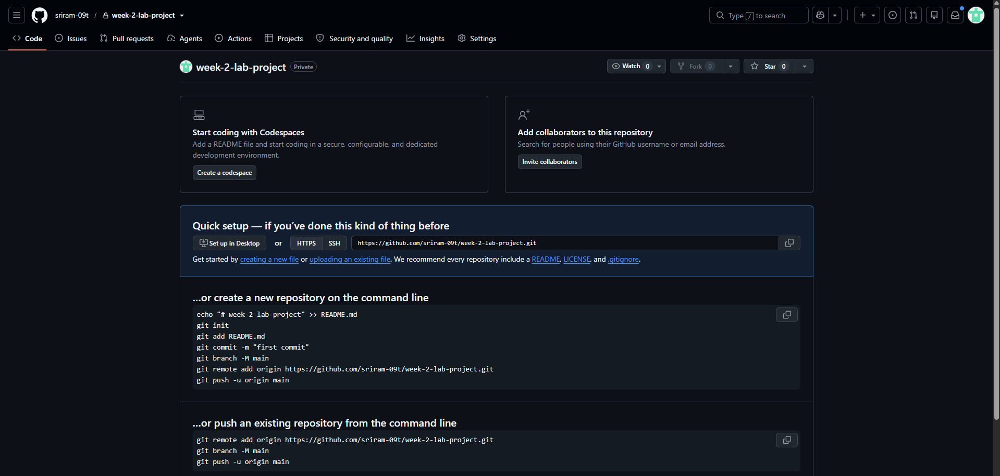
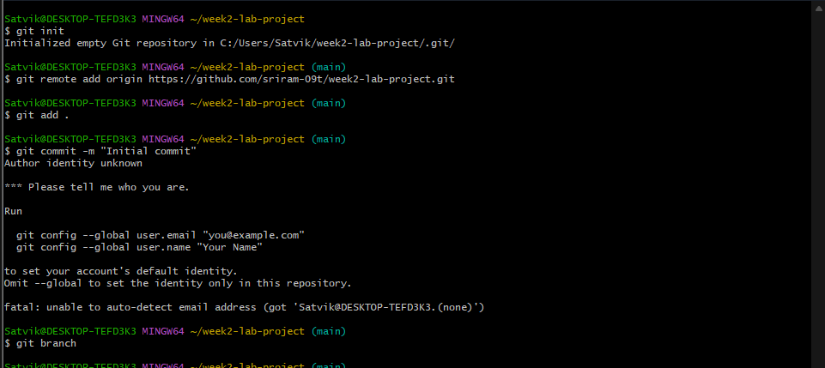
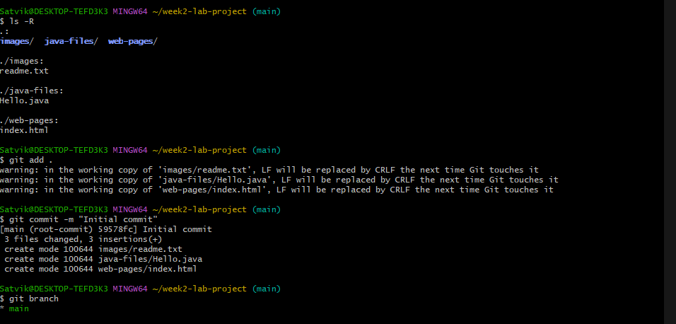
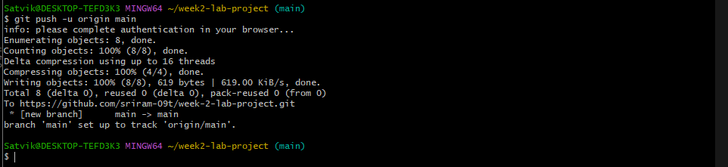

Task -2
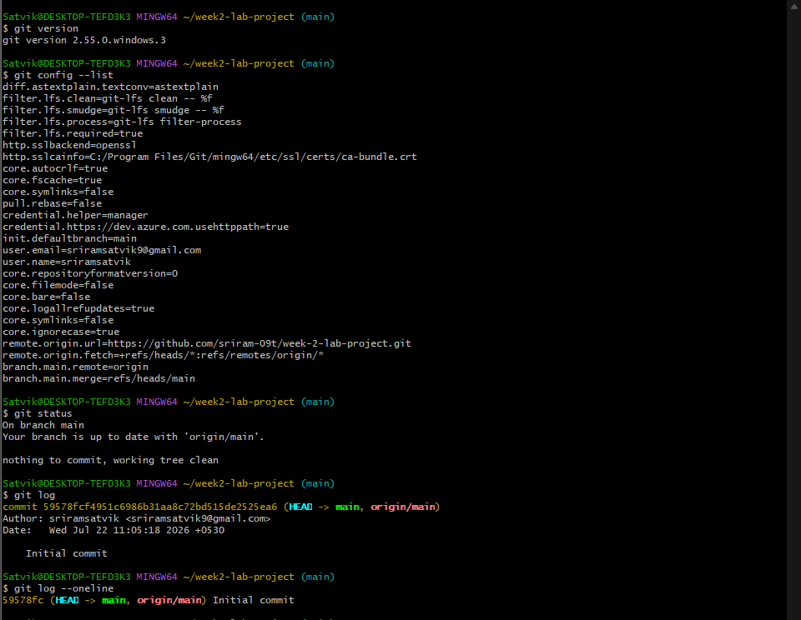
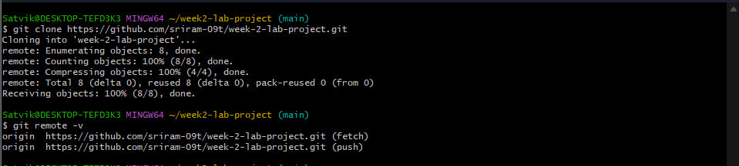
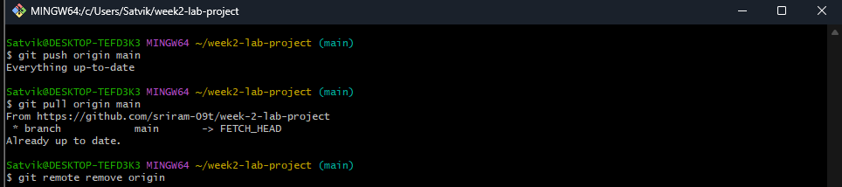
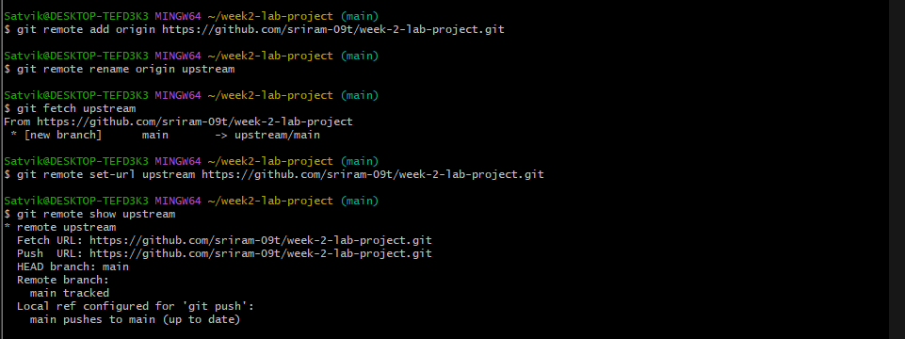
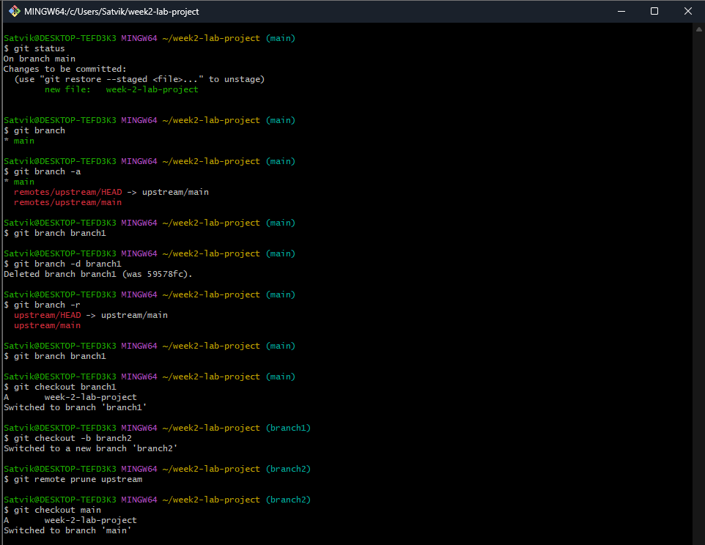
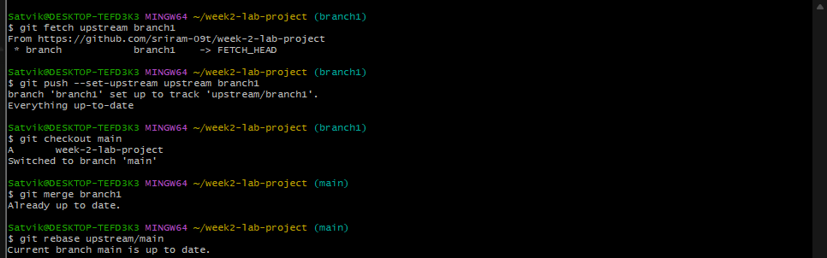
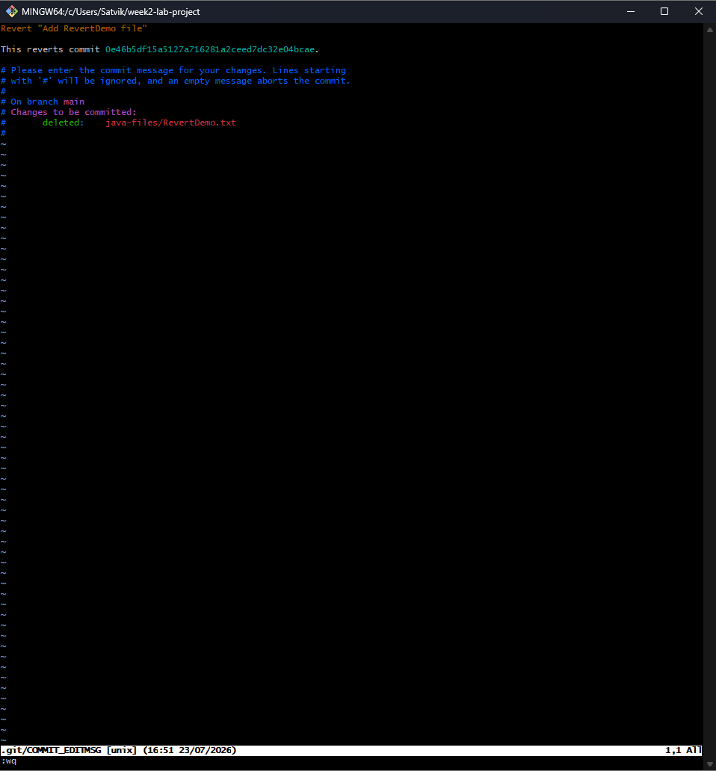
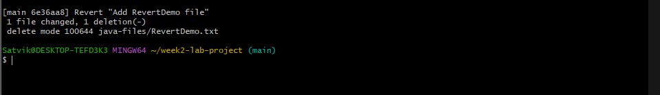
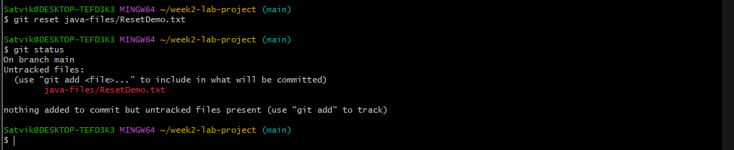
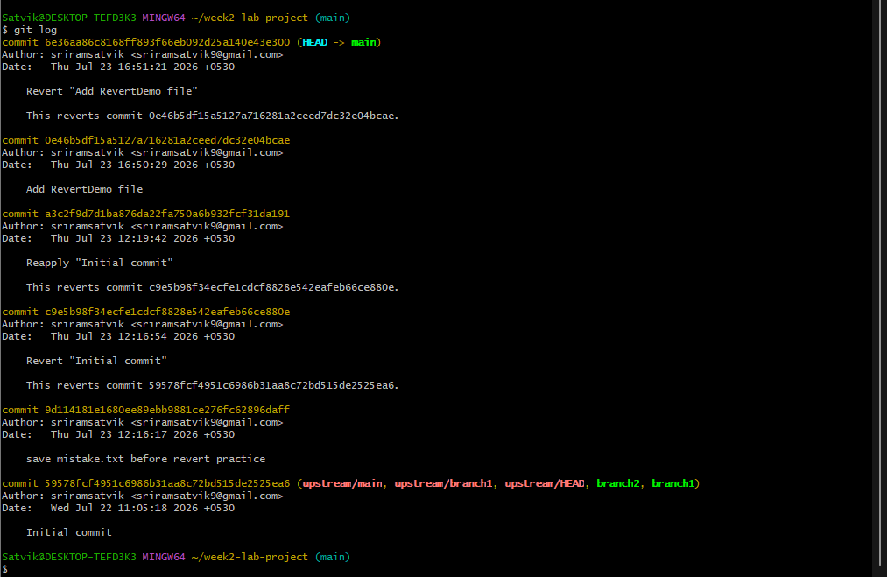
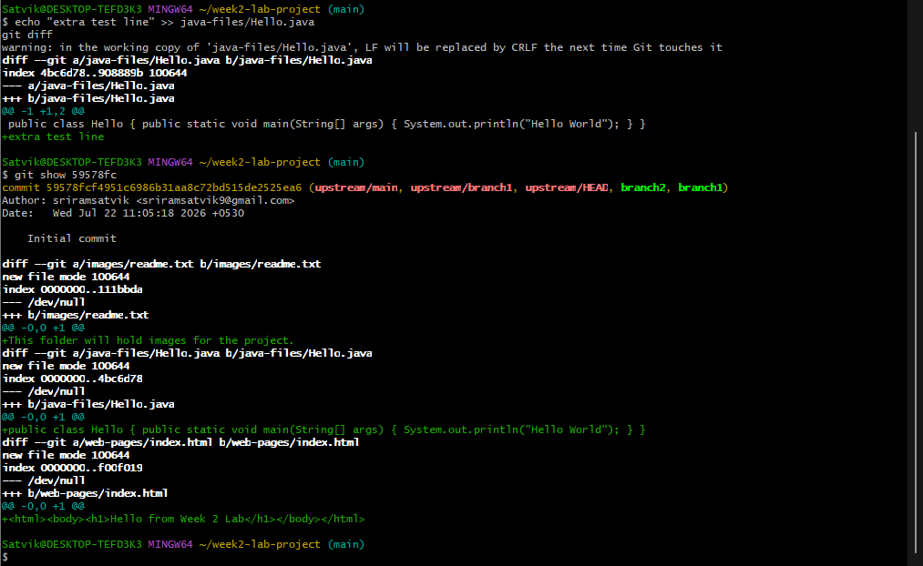
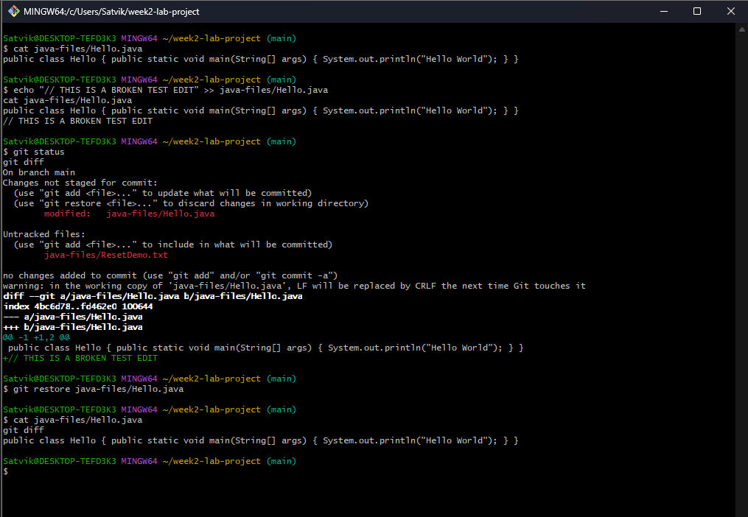
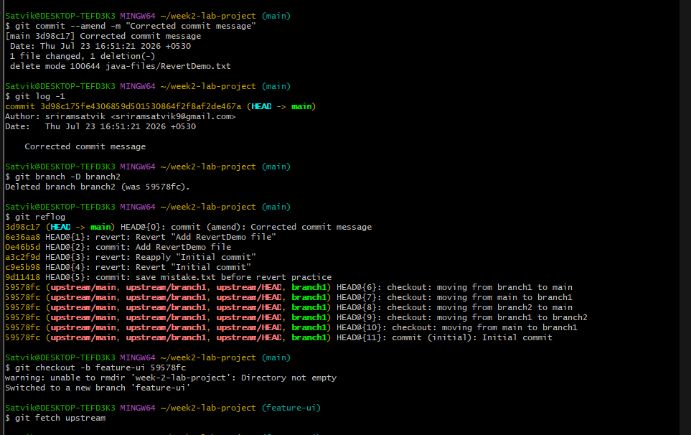
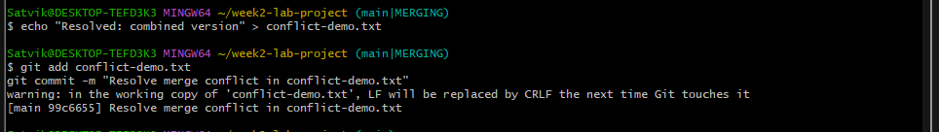
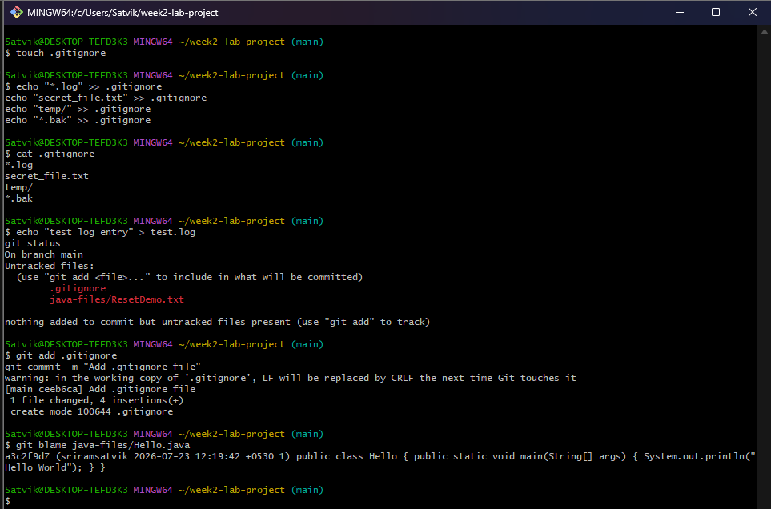
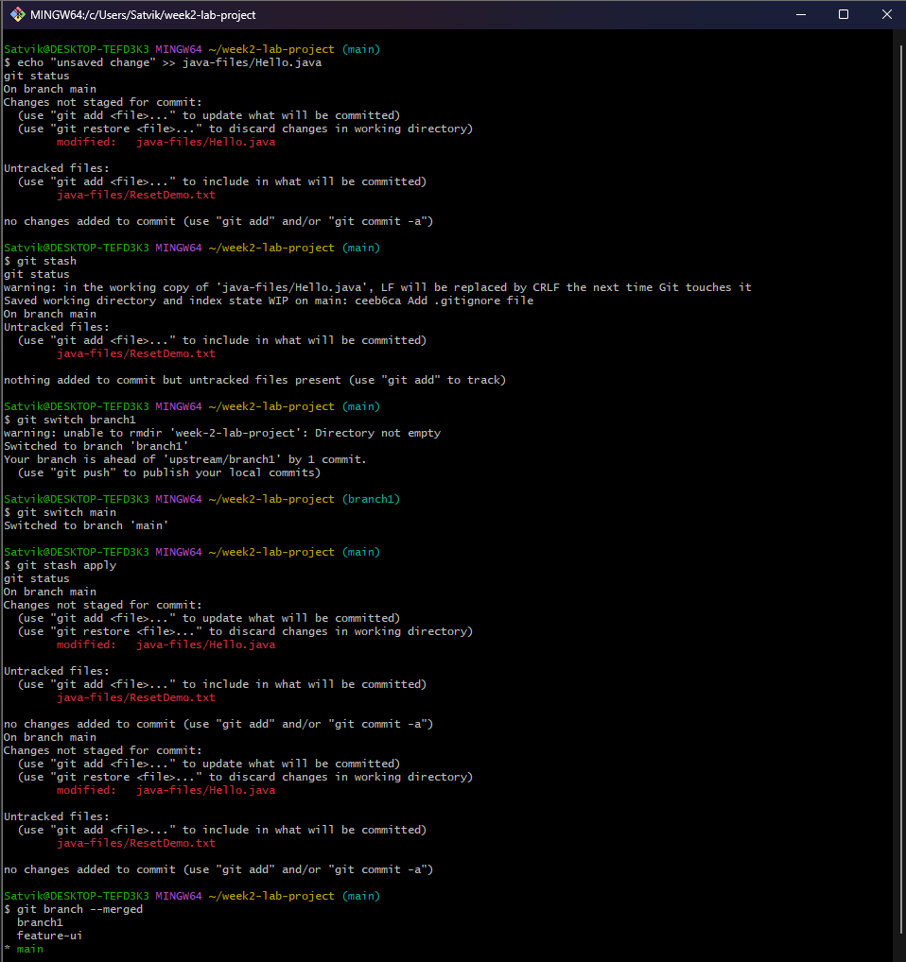
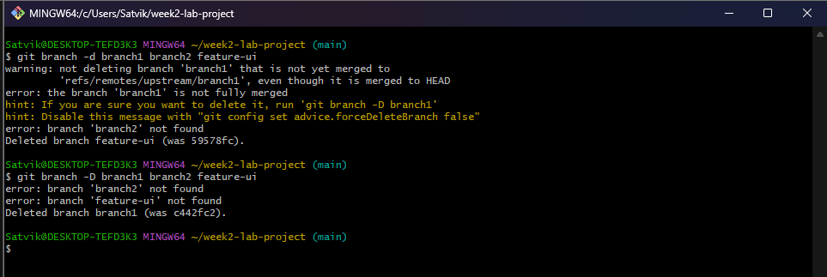
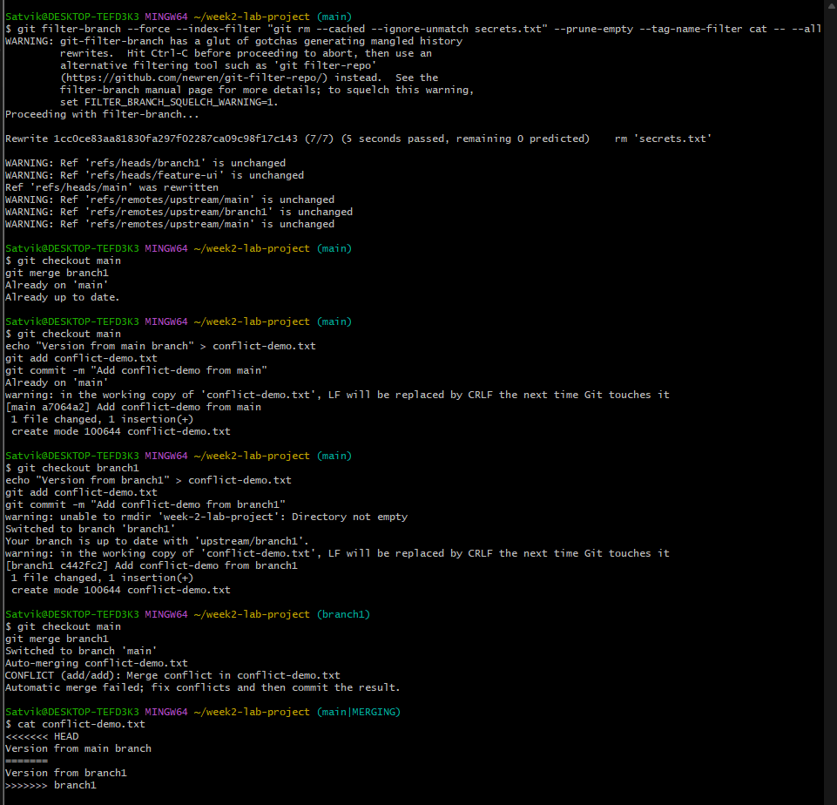
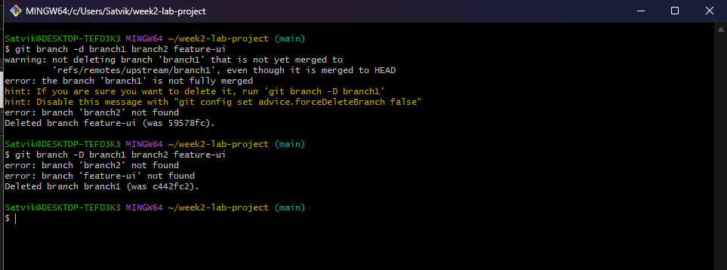

Task 3: Git Scenario-Based Questions
Scenario Based Questions on Basic Git Commands
1. You made changes to one file in the above project but haven't staged them yet. You realize they were a mistake. What Git command will you use to discard the local changes?
Answer: git restore <filename>
2. You accidentally ran git add file1.txt, but you're not ready to commit yet. How do you remove it from the staging area without losing the changes?
Answer: git reset <filename>
3. You made a commit but typed the wrong commit message. You haven't pushed it yet. How do you fix it?
Answer: git commit --amend -m "New corrected message"
4. You want to view the commit history of the current branch in a readable format. What Git command should you use?
Answer: git log --oneline
5. After cloning a repo, how can you set your name and email globally for all Git repositories?
Answer: git config --global user.name "Your Name"
git config --global user.email "xyz@gmail.com"
6. You've made some edits to your files but haven't staged them. How can you view the changes?
Answer: git diff
7. You're on the main branch but need to switch to feature/login. What command do you use?
Answer: git checkout feature/login
8. You deleted the feature-ui branch by mistake. You haven't pushed the deletion. How do you recover it?
Answer: git reflog
git checkout -b feature-ui <commit_hash>
9. You've made some commits locally and now want to upload them to the remote repository. What do you run?
Answer: git push
10. How can you fetch the latest changes from the remote repository without merging them automatically?
Answer: git fetch
11. You're on the main branch and want to start working on a new feature called search-filter. What command do you use?
Answer: git checkout -b search-filter
12. You committed a file containing an API key and want to completely remove it from the repo's history. What should you do?
Answer: git filter-branch --force --index-filter "git rm --cached --ignore-unmatch <file>" --prune-empty --tag-name-filter cat -- --all
13. You want to see all the branches that exist both locally and on the remote. What command do you use?
Answer: git branch -a
14. You're on main and want to merge the completed feature/signup branch into it. What command do you use?
Answer: git checkout main
git merge feature/signup
15. You tried to merge two branches and Git reported a conflict in app.js. What are the general steps to resolve it?
Answer: 1. Open app.js and resolve/remove the conflict markers (<<<<<<<, =======, >>>>>>>)
2. git add app.js
3. git commit
16. You don't want Git to track changes to .log files or node_modules/. How do you achieve this?
Answer: Add these lines to a .gitignore file:
*.log
node_modules/
17. You're investigating a bug and want to know who last changed line 25 in script.py. What command do you use?
Answer: git blame script.py

18. You're in the middle of working on a file but need to switch branches quickly. What do you do to save your work?
Answer: git stash
19. You previously ran git stash and now want to restore those changes. What command do you use?
Answer: git stash apply
20. The feature/test branch is no longer needed. How do you delete it locally?
Answer: git branch -d feature/test
21. You just merged the feature-ui branch into main. You want to clean up your local branches. How do you safely delete feature-ui?
Answer: git branch -d feature-ui
22. You created a branch feature-experiment, made some changes, but now realize the code is no longer needed. You want to delete it, even though it hasn't been merged. What command will you use?
Answer: git branch -D feature-experiment
23. You're currently on the feature-login branch and want to delete feature-ui. What must you ensure before running the delete command?
Answer: You must not currently be checked into feature-ui (switch to another branch first), and confirm you no longer need its changes.
24. You want to delete bugfix-footer, but you're unsure if it's been merged. What should you do before deleting it?
Answer: Run git branch --merged to check if it appears in the list. If not merged, either merge it first or use git branch -D to force delete.
25. You finished working on feature-a, feature-b, and feature-c. All have been merged into main. How do you delete them in one command?
Answer: git branch -d feature-a feature-b feature-c
Scenario Based Questions on Working with Remote Repository
1. Specify the git command when you're starting work on a project and need to clone a remote repository to your local machine.
Answer: git clone <repository_url>

2. Specify the git command if you want to see the remotes that are connected to your local repository.
Answer: git remote -v
3. Specify the git command if you want to add a new remote repository to your local repository.
Answer: git remote add origin <repository_url>
4. Specify the git command to remove a remote repository from your local configuration.
Answer: git remote remove origin
5. Specify the git command if you want to rename an existing remote.
Answer: git remote rename origin upstream
6. Specify the git command to fetch updates from the remote repository but not merge them into your local branch.
Answer: git fetch origin
7. Specify the git command to pull the latest changes from the remote repository and merge them into your local branch.
Answer: git pull origin main
8. Specify the git command to push your local commits to a remote repository.
Answer: git push origin main
9. Specify the git command to use when pushing for the first time and want to set the remote branch you are pushing to.
Answer: git push --set-upstream origin main
10. Specify the git command to change the URL of a remote (e.g., after changing the remote repository address).
Answer: git remote set-url origin <new_url>
11. Specify the git command if you want to list all branches on the remote repository.
Answer: git branch -r
12. Specify the git command if a branch was deleted on the remote but still shows up locally.
Answer: git remote prune origin
13. Specify the git command to fetch a specific branch from a remote.
Answer: git fetch origin <branch_name>

14. Specify the git command if you want to see detailed information about a remote repository.
Answer: git remote show origin
15. Specify the git command if you want to rebase your local branch onto a remote branch.
Answer: git fetch origin
git rebase origin/main

